AAPD7112 part 1
ST10538212 NEO MEI KUBUSHI

Question 1

Five User Engagement Strategies Identified
- Multilingual & Culturally Localised Interface – Supporting South Africa’s 11 official languages and culturally intuitive navigation.
- Simplified, Low-Data Reporting Workflows – Streamlined forms and offline functionality for users with limited connectivity or data.
- Real-Time Feedback & Transparent Tracking – Visible progress updates, reference numbers, and status notifications for every submission.
- Community Based Two-Way Communication – Interactive channels for citizens to ask questions, give input, and receive clear, jargon-free responses.
- Accessible, Inclusive Design – Compliance with accessibility standards for users with disabilities, low-literacy friendly layouts, and voice guidance options.

Selected Strategy: Simplified, Low-Data Reporting Workflows with Offline Support

Explanation & Justification

South Africa’s municipal landscape is deeply varied: while some areas have reliable infrastructure, many communities especially in distressed and underserviced municipalities face limited internet access, high data costs, and inconsistent connectivity. Hart et al. (2019) emphasise that for public services to succeed, they must be built around the realities of users’ daily lives, not just ideal technical specifications. This is why simplified, low-data reporting workflows with offline functionality is the most critical engagement strategy for this application.
At its core, this strategy means replacing long, complex forms with short, step-by-step inputs that require minimal data to submit. Citizens can report issues such as burst pipes, power outages, or waste collection problems using just a few fields: location, category, and a short description. Image uploads are optional and compressed to use as little data as possible.

Most importantly, the app allows users to draft and save reports offline, then submit automatically once they reconnect to any network, removing the frustration of lost entries due to signal drops.

This choice is rooted in both equity and practicality. Data costs remain a major barrier across South Africa, particularly for low-income households who rely most on municipal services. If an app is too data-heavy or requires constant connectivity, it effectively excludes the communities that need it most. By designing for low-bandwidth and offline use, the municipality ensures that every resident regardless of their access to technology can participate and be heard.
It also builds trust: when citizens see that the system is made for their circumstances, they are far more likely to use it regularly and engage constructively with municipal services.
This strategy also benefits the municipality: clearer, more complete reports lead to faster responses, fewer follow-up queries, and better resource planning. In this way, the design does not just improve usability it strengthens the relationship between the state and the public, turning a simple reporting tool into a foundation for more responsive, citizen-centred governance.

References
Hart, T. G. B., et al. (2019). Innovation for Development in South Africa: Experiences with Basic Service Technologies in Distressed Municipalities. Forum for Development Studies, 47(1), 23–47. [Accessed 20 February 2025]

Question 2
Report issues button activated
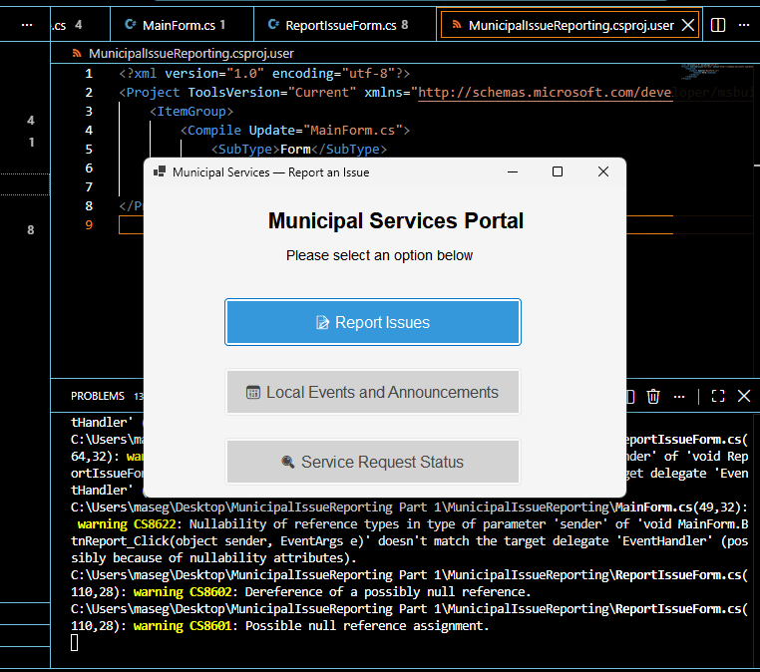
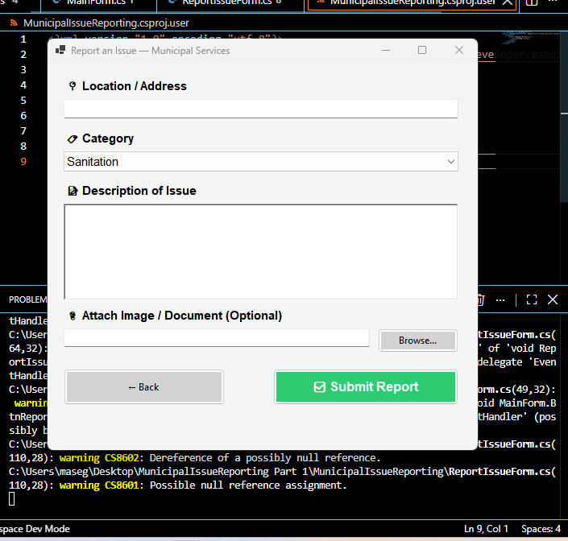
Drop down error has options available
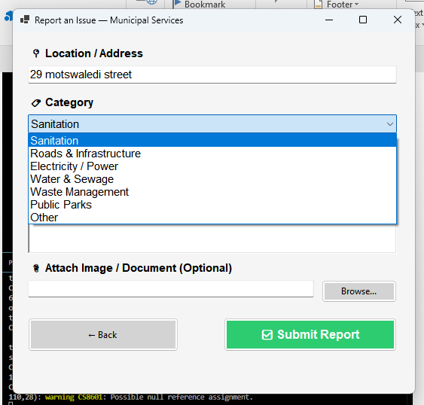
Issue reported and form submitted
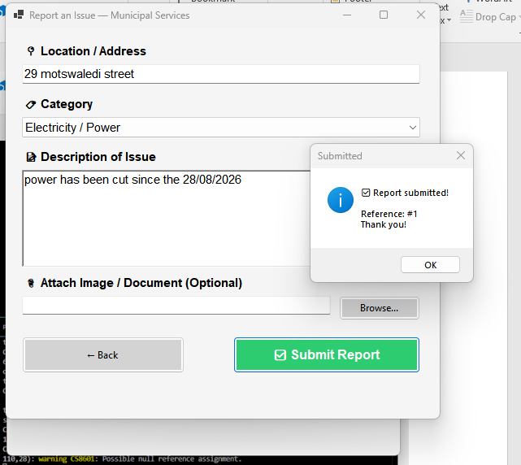
Attaching an image option works
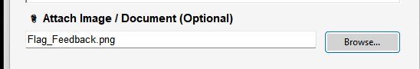
Local events and Announcements button Activated
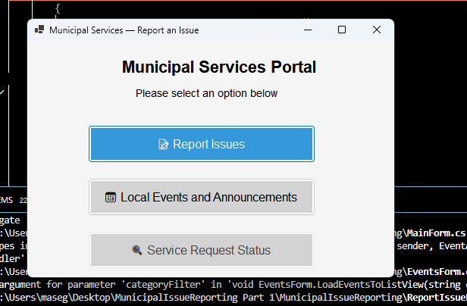
Different events to view
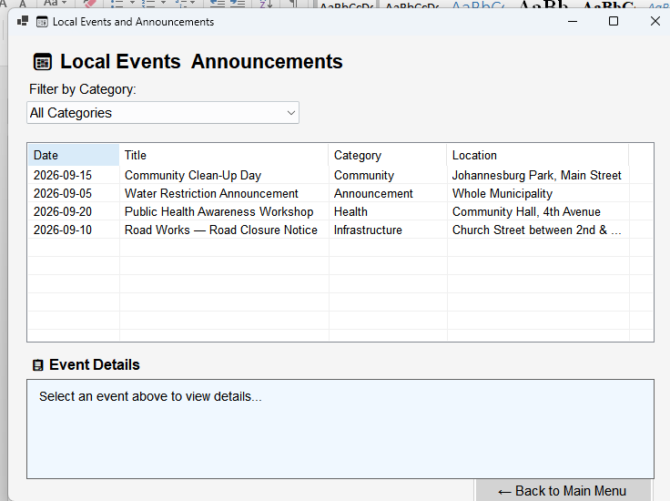
Filter by Category drop down with options
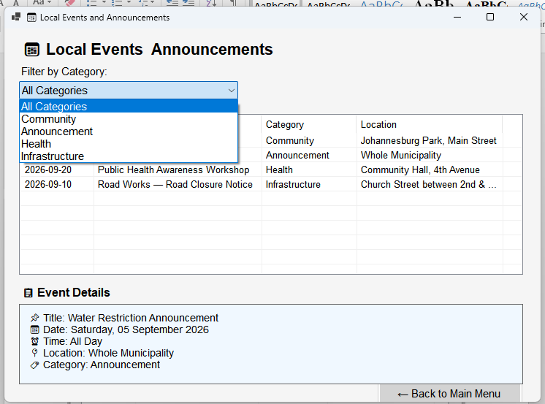
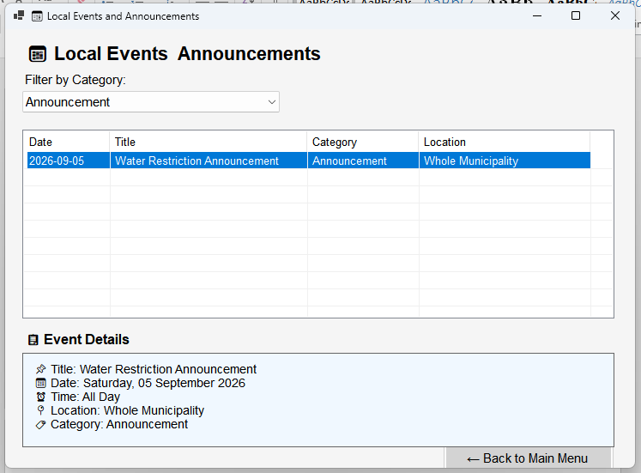
Service request Button Activated
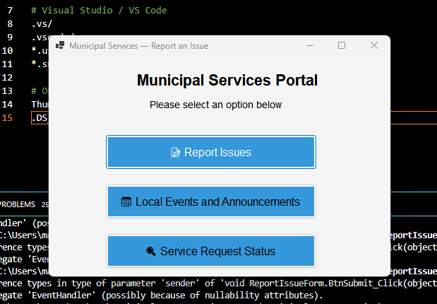
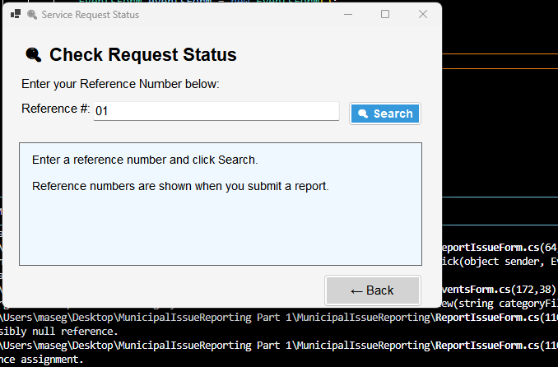
When an invalid reference is used
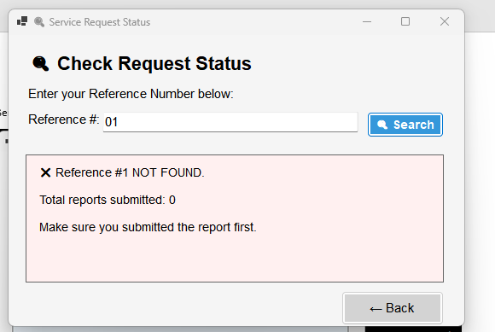

Git hub Commits
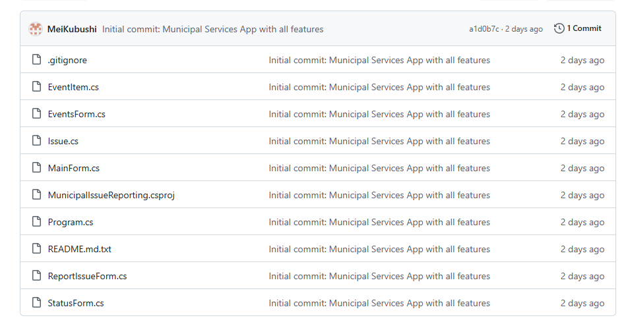

Github link :
MeiKubushi/MunicipalIssueReporting

